Handwritten Digital Recognition using OpenCv and CNNs
Project Report Submitted in partial fulfilment of the requirements for the award of the degree of

BACHELOR OF TECHNOLOGY

ARTIFICIAL INTELLIGENCE AND DATA SCIENCE
Submitted by

Roll No | Name | Dept. | Year
23000890224 | P. Venkata Vijay Siva Reddy | AI&DS | 3rd year
2300080155 | Ch.Aditya | AI&DS | 3rd year
2300080008 | B.Bhargav | AI&DS | 3rd year
2300089012 | T. Maihar Sai | AI&DS | 3rd year

Course Code: 23SDAD10R

Course title: COMPUTER VISION USING OPENCV

Under the esteemed guidance of
Faculty Name: Dr. Venkata Daya Sagar Ketaraju
Designation: Assoc. Professor



Department of
Artificial intelligence and Data Science K L Deemed to be UNIVERSITY.
Green Fields, Vaddeswaram, Andhra Pradesh 522501
2025-26

KL DEEMED TO BE UNIVERSITY
Green Fields, Vaddeswaram, Andhra Pradesh 522501
CERTIFICATE
This is to certify that the COMPUTER VISION USING OPENCV course project report entitled “Handwritten Digital Recognition using OpenCv” submitted by P. Venkata Vijay Siva Reddy (23000890224), Ch.Aditya (2300080155), B.Bhargav (2300080008), T. Maihar Sai (2300089012) in partial fulfillment of the requirements for the award of theDegree Bachelor of Technology in “Artificial Intelligence & Data Science” is a bonafied record of the work carried out under our guidance and supervision at K L Deemed to be University during the academic year 2025-26.

Signature of Guide Head of The Department Faculty: Dr. Venkata Daya Sagar Ketaraju
Designation: Assoc. Professor

ACKNOWLEDGEMENT

We are greatly indebted to our KL Deemed to be University that has provided a healthy environment to drive us to achieve our ambitions and goals. We would like to express our sincere thanks to our project guide Dr .Venkata Daya Sagar Ketaraju, Assoc. Professor for the guidance, support and assistance they have provided in completing this project.
We are thankful to our Head of the Department Dr.VSV.Prabhakar, Professor, Dept. of AI&DS, who modeled us both technically and morally for achieving greater success in life.
We are very much glad for having the support given by our principal, Dr.V.Rajesh who inspired us with his words filled with dedication and discipline towards work.
Finally, we owe a lot to the teaching and non-teaching staff of the Dept. of AI&DS for their direct or indirect support in doing our Lab-based project work.

P. Venkata Vijay Siva Reddy (23000890224)
Ch.Aditya (2300080155)
B.Bhargav (2300080008)
T. Maihar Sai (2300089012)

INDEX

Content Page No
- ABSTRACT 3
- PROJECT DESCRIPTION 4-6
- SOFTWARE AND HARDWARE REQUIREMENTS 7
- TECHNOLOGIES USED 8-9
- DESCRIPTION OF DATA SET 11-12
- ALGORITHMS IMPLEMENTED 13-15
- SAMPLE CODE SCREENSHOTS 16-25
- CONCLUSION 26
- FUTURE SCOPE 27-28
- REFERENCES 29

ABSTRACT

Handwritten digit recognition has become a critical capability in modern intelligent systems, enabling seamless automation across financial services, postal mail sorting, digital form processing, and human–computer interaction. This project presents a robust approach to Handwritten Digit Recognition by leveraging the power of Convolutional Neural Networks (CNNs) combined with efficient OpenCV-based image preprocessing pipelines. The primary objective is to develop a high-accuracy model capable of recognizing digits from real-world handwritten inputs with minimal preprocessing and maximum generalization.
The system begins by applying OpenCV operations such as grayscale conversion, noise reduction, thresholding, and contour detection to transform raw handwritten images into clean and standardized inputs. These refined images are then fed into a carefully designed CNN architecture, consisting of convolutional layers, ReLU activations, pooling layers, and fully connected layers that learn hierarchical features and spatial patterns from the digit images.
The model is trained and evaluated using benchmark datasets like MNIST, achieving strong accuracy and demonstrating excellent robustness to variations in handwriting style. Experimental results show that the integration of OpenCV’s preprocessing with CNN-based deep learning significantly enhances recognition performance and reduces classification errors.
This work highlights the synergy between classical computer vision and deep learning, offering a scalable, efficient, and real-time-ready solution for handwritten digit classification tasks. The resulting system can be deployed in embedded devices, mobile applications, and enterprise automation platforms, showcasing its adaptability and practical impact.

Keywords:

Handwritten Digit Recognition, CNN, Deep Learning, OpenCV, Image Preprocessing, MNIST, Classification, Computer Vision.

INTRODUCTION

In the era of rapid digital transformation, the ability of machines to interpret human handwriting has emerged as a vital requirement across numerous industries. Handwritten digit recognition stands at the core of this capability, enabling automation in areas such as banking transactions, medical data entry, academic form processing, and logistics. As organizations move toward smarter and more efficient workflows, the demand for accurate and reliable recognition systems continues to grow.
Early approaches to handwritten digit recognition relied on classical machine learning algorithms such as Support Vector Machines (SVM), K-Nearest Neighbors (KNN), and decision trees. While effective to an extent, these models required extensive manual feature extraction and were often sensitive to variations in handwriting styles, orientation, and noise. This created limitations in terms of scalability, adaptability, and real-world performance.
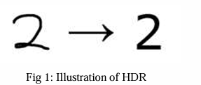
The rise of deep learning—particularly Convolutional Neural Networks (CNNs)—revolutionized the domain by enabling models to learn spatial hierarchies and abstract patterns directly from raw image pixels. CNNs outperform traditional methods because they automatically extract low-level and high-level features, making them highly robust to changes in size, shape, and writing patterns. Their strong generalization capability has made them the de facto standard for image classification tasks.
At the same time, OpenCV, a powerful open-source computer vision library, provides efficient tools for image preprocessing. Operations such as grayscale conversion, noise filtering, binarization, morphological operations, and contour detection help standardize input images, making the CNN more effective during training and inference. By combining OpenCV’s preprocessing pipeline with a CNN-based deep learning model, this system achieves both high accuracy and real-time performance.
This project aims to design and implement a complete handwritten digit recognition system that leverages the strengths of both computer vision and deep neural networks. The system is trained on benchmark datasets like MNIST, ensuring consistency and comparability with existing literature. The resulting model demonstrates strong accuracy, robustness to handwriting variations, and practical applicability across multiple real-world domains.
Ultimately, this work contributes toward building smarter, adaptive, and scalable recognition systems that can seamlessly integrate into modern digital infrastructures.

Objectives:

Build a system that recognizes handwritten digits using OpenCV and CNNs.

Preprocess input images for clean, consistent model predictions.

Design and train a high-accuracy CNN model.

Enable real-time digit detection from images or camera input.

Validate performance using accuracy metrics and testing.

Provide a simple interface for users to draw or upload digits.

Document setup, usage, and deployment clearly.

Problem Statement:

Handwritten digit recognition remains a critical challenge in automating data entry, document processing, and digital authentication workflows. Traditional manual transcription introduces delays, increases operational overhead, and is prone to human error. Despite the availability of various machine learning solutions, many lack the capability to efficiently process real-world handwritten inputs that vary widely in style, thickness, size, rotation, and noise.

System Overview
The system architecture includes:

- The system captures input from images or a live camera stream.
- OpenCV preprocesses the image using grayscale conversion, thresholding, denoising, and contour detection.
- The digit region is extracted, resized, and normalized for consistent CNN input.
- A trained CNN model performs feature extraction and classifies the digit.
- The model returns a prediction along with confidence levels.
- Results are presented to the user through a simple interface in real time.
- Modular design enables easy upgrades, customization, and integration into larger applications.

SOFTWARE AND HARDWARE REQUIREMENT:

Software requirements:

- Operating System:
• Windows / Linux / macOS
- Programming Language:
• Python 3.x
- Libraries and Frameworks:
• OpenCV – for image preprocessing (grayscale, thresholding, contour extraction)
• TensorFlow / Keras or PyTorch – for building and training the CNN model
• NumPy – for numerical and matrix computations
• Matplotlib – for visualizing training accuracy and loss
• Scikit-learn – for evaluation metrics (confusion matrix, classification report)
• pandas – for dataset handling (optional)
- Development Environment / IDE:
• PyCharm
• Visual Studio Code
• Jupyter Notebook / Google Colab
- Optional Tools:
• OpenCV GUI modules or Tkinter/PyQt5 for building a simple user interface
• CUDA Toolkit (if training with GPU support)
• Anaconda – for environment and dependency management

Hardware Requirements:

Processor: Intel i3/i5 or higher
RAM: 4 GB (8 GB recommended)
GPU: Optional (NVIDIA recommended for faster training)
Webcam: Optional (for real-time input)
Storage: 2 GB free space
Standard monitor, mouse, and keyboard

TECHNOLOGIES USED

- OpenCV

Description:
OpenCV (Open Source Computer Vision Library) is a powerful, open-source computer vision and image processing framework widely used for analyzing and manipulating visual data. It provides hundreds of functions for operations like filtering, thresholding, contour detection, and image transformations.
Purpose in Project:
OpenCV handles the entire preprocessing pipeline—converting handwritten digit images to grayscale, removing noise, applying thresholding, extracting contours, isolating the digit region, and resizing it into a format the CNN can accurately interpret.
Key Advantages:
- Fast and optimized image processing performance
- Large library of prebuilt functions
- Seamless integration with NumPy arrays
- Highly efficient for real-time detection
- Cross-platform and easy to use with Python

- TensorFlow / Keras or PyTorch

Description:
TensorFlow (with Keras API) and PyTorch are leading deep learning frameworks that enable building, training, and deploying neural networks. They provide tools for defining CNN layers, optimizing parameters, and managing datasets with GPU acceleration.
Purpose in Project:
These frameworks are used to design, train, and evaluate the Convolutional Neural Network (CNN) that recognizes handwritten digits. They handle forward/backward propagation, weight updates, loss calculations, and model optimization.
Key Advantages:
- User-friendly APIs for building deep learning models
- GPU/TPU support for faster training
- Strong community support and documentation
- Easy model saving, loading, and deployment
- High performance for complex neural networks

- NumPy

Description:
NumPy is the core Python library for numerical and matrix operations. It offers fast, vectorized computations and is the foundation for many machine learning and scientific libraries.
Purpose in Project:
NumPy supports data manipulation, preprocessing, reshaping images into arrays, performing matrix operations, and linking efficiently with OpenCV and deep learning frameworks.
Key Advantages:
- Extremely fast numerical operations
- Efficient handling of large arrays and matrices
- Integrates seamlessly with OpenCV, TensorFlow, and PyTorch
- Essential for preprocessing and data transformations

4. Matplotlib
Description:
Matplotlib is a Python plotting library used for creating static, interactive, and animated visualizations. It supports charts such as line plots, histograms, bar charts, and image displays.
Purpose in Project:
It is used to visualize training results, including accuracy curves, loss curves, sample predictions, and dataset images, helping analyze model performance and tuning quality.
Key Advantages:
- Easy to create high-quality graphs
- Ideal for visualizing neural network training
- Supports image visualization for debugging
- Highly customizable plotting options

- Scikit-Learn

Description:
Scikit-learn is a machine learning library that provides tools for preprocessing, model evaluation, and classical algorithms. It includes ready-made functions for metrics and data splitting.
Purpose in Project:
It is used to compute evaluation metrics for the CNN, such as the confusion matrix, accuracy score, precision, recall, and classification reports, ensuring a complete performance analysis.
Key Advantages:
- Reliable and easy-to-use evaluation tools
- Provides essential metrics to benchmark model quality
- Integrates smoothly with NumPy arrays
- Lightweight and fast

- pandas (Optional)

Description:
pandas is a high-performance data manipulation library that provides easy-to-use data structures such as DataFrames for managing structured datasets.
Purpose in Project:
While not mandatory, pandas can help in managing custom datasets, logging predictions, creating result tables, or loading external CSV-based digit datasets.
Key Advantages:
- Excellent for structured data handling
- Simplifies dataset loading and preprocessing
- Integrates with NumPy and Matplotlib
- Useful for analysis and reporting

DESCRIPTION OF DATA SET

The dataset used for this project is the MNIST Handwritten Digit Dataset, a widely adopted benchmark collection of grayscale images representing handwritten digits from 0 to 9. It contains a diverse set of samples written by thousands of individuals, ensuring variations in writing styles, stroke thickness, size, and orientation. Each image is standardized to a 28×28 pixel resolution and stored in a consistent format suitable for training machine-learning and deep-learning models. The dataset is pre-labeled, making it ideal for supervised learning tasks and for evaluating the performance of convolutional neural networks.

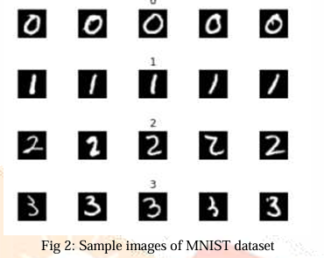

Key Characteristics of the Dataset

- Image Count
  - 60,000 training images
  - 10,000 testing images
  - Total: 70,000 handwritten digit samples
- Image Format
  - Grayscale images (single channel)
  - Fixed size: 28 × 28 pixels
  - Pixel values range from 0 to 255, typically normalized to 0–1
- Classes (Labels)
  - 10 unique classes representing digits:
0, 1, 2, 3, 4, 5, 6, 7, 8, 9
- Data Structure
  - Each image has an associated label indicating the correct digit
  - Stored in arrays compatible with NumPy, TensorFlow, and PyTorch
- Variations in Writing Styles
  - Includes thick, thin, slanted, curved, and stylized handwriting
  - Provides wide diversity, improving model generalization
- Noise and Realistic Imperfections
  - Contains natural handwriting noise
  - Mimics variations seen in real-world applications (forms, notes, etc.)

Purpose of Using This Dataset
- To train and validate a CNN capable of recognizing handwritten digits accurately
- To evaluate preprocessing quality performed using OpenCV
- To benchmark deep learning models against a standard digit-recognition dataset
- To ensure robustness and generalization in real-world digit processing systems

Why This Dataset is Ideal for the Project
- Highly standardized and well-labeled
- Clean enough for fast prototyping
- Complex enough to challenge and improve CNN performance
- Widely supported by all major machine-learning frameworks
- Enables easy comparison with existing research and models

ALGORITHMS IMPLEMENTED

1.Image Preprocessing for Drawn Digits

- Convert the user-drawn canvas image to grayscale using PIL.
- Apply inversion (white → black, black → white) to match MNIST digit style.
- Use binary thresholding (OpenCV) to isolate the handwritten strokes.
- Detect the bounding box of the digit using cv2.findNonZero() and crop the region of interest.
- Resize the digit to 20×20 pixels and embed it in a 28×28 centered canvas to match MNIST format.
- Normalize pixel values to the 0–1 range to improve CNN prediction stability.

2. MNIST Dataset Preprocessing
- Load the MNIST dataset consisting of 60,000 training and 10,000 testing samples using Keras.
- Normalize pixel values from 0–255 to 0–1 for faster training.
- Expand dimensions to match CNN input shape: (28, 28, 1).
- Convert labels into one-hot encoded vectors using to_categorical() for multi-class classification.
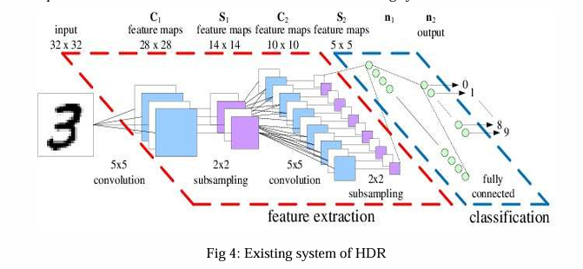

3. Data Augmentation
- Use Keras ImageDataGenerator to generate realistic variations of handwritten digits:
  - Rotation (±10°)
  - Width and height shifts
  - Zoom and shear transformations
- Enriches the dataset and gives the CNN stronger generalization to messy or uneven handwriting.
- Prevents overfitting by introducing noise and variability during training.

4. Convolutional Neural Network (CNN) Feature Extraction
- Apply stacked Conv2D layers (32, 64, 128 filters) to learn digit features such as:
  - Edges
  - Curves
  - Strokes
  - Pixel orientations
- Integrate Batch Normalization after each convolution to stabilize gradients.
- Apply ReLU activation for non-linear feature learning.
- Use MaxPooling layers to reduce spatial dimensions while preserving important features.
- Add Dropout layers to prevent overfitting.

5. Deep Neural Network Classification Layers
- Flatten the extracted feature maps into a 1D vector.
- Dense layers (256 → 128 neurons) transform high-level features into digit patterns.
- Apply BatchNorm + ReLU + Dropout for:
  - Faster convergence
  - Better model regularization
  - Higher accuracy
- Final Dense(10, softmax) outputs probability scores for digits 0–9.

6. Model Training and Optimization
- Use Adam optimizer with a learning rate of 0.001 for efficient gradient descent.
- Compute categorical cross-entropy loss to measure prediction errors.
- Fit the model using augmented data + real MNIST samples.
- Validate using test data to measure model generalization and accuracy.

7. Prediction and Confidence Scoring
- Preprocessed 28×28 image is passed through the CNN.
- Softmax activation outputs a probability distribution.
- The predicted digit is determined using argmax().
- Confidence score is calculated as the probability × 100% of the predicted digit.

8. GUI Input Capture Algorithm
- Capture the user’s drawing strokes on a Tkinter canvas.
- Convert drawn strokes into a PIL image with white background.
- Apply preprocessing pipeline to create a digit image suitable for prediction.
- Display the predicted digit and confidence score in real-time once the user clicks "Recognize".

9. ARCHITECTURE

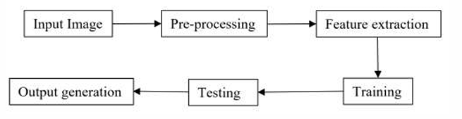

SAMPLE CODE SCREENSHOTS

digital_recognition.py:

import os
import numpy as np
import tensorflow as tf
from tensorflow import keras
from tensorflow.keras import layers, models, optimizers
from tensorflow.keras.datasets import mnist
from tensorflow.keras.utils import to_categorical
from tensorflow.keras.preprocessing.image import ImageDataGenerator
import cv2
import tkinter as tk
from tkinter import messagebox
from PIL import Image, ImageDraw
import io
import warnings

warnings.filterwarnings('ignore')

# ===============================================================
# ADVANCED CNN MODEL CLASS
# ===============================================================
class AdvancedDigitRecognitionModel:

def __init__(self, model_path='digit_model.h5'):
self.model_path = model_path
self.model = None
self.is_trained = False

def build_model(self):
print("[*] Building Advanced CNN Model...")

model = models.Sequential([
layers.Conv2D(32, (3, 3), padding='same', input_shape=(28, 28, 1)),
layers.BatchNormalization(),
layers.Activation('relu'),
layers.Conv2D(32, (3, 3), padding='same'),
layers.BatchNormalization(),
layers.Activation('relu'),
layers.MaxPooling2D((2, 2)),
layers.Dropout(0.25),

layers.Conv2D(64, (3, 3), padding='same'),
layers.BatchNormalization(),
layers.Activation('relu'),
layers.Conv2D(64, (3, 3), padding='same'),
layers.BatchNormalization(),
layers.Activation('relu'),
layers.MaxPooling2D((2, 2)),
layers.Dropout(0.25),

layers.Conv2D(128, (3, 3), padding='same'),
layers.BatchNormalization(),
layers.Activation('relu'),
layers.Conv2D(128, (3, 3), padding='same'),
layers.BatchNormalization(),
layers.Activation('relu'),
layers.MaxPooling2D((2, 2)),
layers.Dropout(0.25),

layers.Flatten(),
layers.Dense(256),
layers.BatchNormalization(),
layers.Activation('relu'),
layers.Dropout(0.5),

layers.Dense(128),
layers.BatchNormalization(),
layers.Activation('relu'),
layers.Dropout(0.5),

layers.Dense(10, activation='softmax')
])

model.compile(
optimizer=optimizers.Adam(learning_rate=0.001),
loss='categorical_crossentropy',
metrics=['accuracy']
)

self.model = model
print("[✓] Model Built Successfully")
return model

def train(self, X_train, y_train, X_test, y_test, epochs=20, batch_size=128):
if self.model is None:
self.build_model()

print("[*] Training Model with Data Augmentation...")

data_augmentation = ImageDataGenerator(
rotation_range=10,
width_shift_range=0.1,
height_shift_range=0.1,
zoom_range=0.1,
shear_range=0.1,
fill_mode='nearest'
)

history = self.model.fit(
data_augmentation.flow(X_train, y_train, batch_size=batch_size),
epochs=epochs,
validation_data=(X_test, y_test),
verbose=1,
steps_per_epoch=len(X_train) // batch_size
)

self.is_trained = True
print("[✓] Model Training Completed")
return history

def save_model(self):
if self.model is not None:
self.model.save(self.model_path)
print(f"[✓] Model saved to {self.model_path}")

def load_model(self):
if os.path.exists(self.model_path):
self.model = keras.models.load_model(self.model_path)
self.is_trained = True
print(f"[✓] Model loaded from {self.model_path}")
return True
return False

def predict(self, image_array):
if self.model is None:
return None, None

image_array = np.expand_dims(image_array, axis=-1)
image_array = np.expand_dims(image_array, axis=0)

predictions = self.model.predict(image_array, verbose=0)
digit = np.argmax(predictions[0])
confidence = float(predictions[0][digit]) * 100

return digit, confidence

# ===============================================================
# DATA PREPROCESSOR
# ===============================================================
class DataProcessor:
@staticmethod
def load_and_preprocess_data():
print("[*] Loading MNIST Dataset...")

(X_train, y_train), (X_test, y_test) = mnist.load_data()

X_train = X_train.astype('float32') / 255.0
X_test = X_test.astype('float32') / 255.0

X_train = np.expand_dims(X_train, axis=-1)
X_test = np.expand_dims(X_test, axis=-1)

y_train = to_categorical(y_train, 10)
y_test = to_categorical(y_test, 10)

print("[✓] MNIST Preprocessing Complete")

return X_train, y_train, X_test, y_test

# ===============================================================
# DRAWN IMAGE PREPROCESSOR – FIXED VERSION
# ===============================================================
class CanvasImageProcessor:

@staticmethod
def preprocess_drawn_digit(image):
if image is None:
return None

img = image.convert('L')
img = np.array(img)

# invert (white bg -> 0, black digit -> 255)
img = 255 - img

# threshold
_, img = cv2.threshold(img, 30, 255, cv2.THRESH_BINARY)

# find bounding box
coords = cv2.findNonZero(img)
x, y, w, h = cv2.boundingRect(coords)

# crop
img = img[y:y+h, x:x+w]

# resize to 20x20
img = cv2.resize(img, (20, 20), interpolation=cv2.INTER_AREA)

# create 28x28 canvas
canvas = np.zeros((28, 28), dtype=np.float32)
offset_x = (28 - 20) // 2
offset_y = (28 - 20) // 2
canvas[offset_y:offset_y + 20, offset_x:offset_x + 20] = img

# normalize
canvas /= 255.0

return canvas

# ===============================================================
# GUI FOR DIGIT RECOGNITION
# ===============================================================
class DigitRecognitionGUI(tk.Tk):

def __init__(self, model):
super().__init__()

self.model = model

self.title("Handwritten Digit Recognition - CNN")
self.geometry("900x700")
self.resizable(False, False)

self.canvas_width = 280
self.canvas_height = 280
self.last_x = 0
self.last_y = 0
self.drawing = False

self.setup_ui()

def setup_ui(self):
title = tk.Label(
self, text="Handwritten Digit Recognition using CNN",
font=("Arial", 20, "bold")
)
title.pack(pady=15)

frame = tk.Frame(self)
frame.pack(pady=10)

# drawing canvas
self.canvas = tk.Canvas(
frame, width=self.canvas_width, height=self.canvas_height,
bg="white", bd=2, relief=tk.SUNKEN, cursor="cross"
)
self.canvas.pack(side=tk.LEFT, padx=20)

self.canvas.bind("<Button-1>", self.start_draw)
self.canvas.bind("<B1-Motion>", self.draw)
self.canvas.bind("<ButtonRelease-1>", self.stop_draw)

right_frame = tk.Frame(frame)
right_frame.pack(side=tk.RIGHT)

self.result_digit = tk.Label(
right_frame, text="?",
font=("Arial", 80, "bold"), fg="blue"
)
self.result_digit.pack(pady=20)

self.confidence_label = tk.Label(
right_frame, text="Confidence: 0%",
font=("Arial", 14)
)
self.confidence_label.pack(pady=10)

tk.Button(
right_frame, text="Recognize", font=("Arial", 12, "bold"),
bg="#27ae60", fg="white", padx=15, pady=10,
command=self.recognize_digit
).pack(pady=10)

tk.Button(
right_frame, text="Clear", font=("Arial", 12, "bold"),
bg="#e74c3c", fg="white", padx=15, pady=10,
command=self.clear_canvas
).pack(pady=10)

# Draw controls
def start_draw(self, event):
self.last_x = event.x
self.last_y = event.y
self.drawing = True

def draw(self, event):
if self.drawing:
self.canvas.create_line(
self.last_x, self.last_y, event.x, event.y,
fill="black", width=20, capstyle=tk.ROUND, smooth=True
)
self.last_x = event.x
self.last_y = event.y

def stop_draw(self, event):
self.drawing = False

def clear_canvas(self):
self.canvas.delete("all")
self.result_digit.config(text="?")
self.confidence_label.config(text="Confidence: 0%")

# Capture and recognize
def get_canvas_image(self):
img = Image.new("RGB", (self.canvas_width, self.canvas_height), "white")
draw = ImageDraw.Draw(img)

for item in self.canvas.find_all():
coords = self.canvas.coords(item)
if len(coords) >= 4:
for i in range(0, len(coords)-2, 2):
draw.line(
(coords[i], coords[i+1], coords[i+2], coords[i+3]),
fill="black", width=20
)
return img

def recognize_digit(self):
img = self.get_canvas_image()
processed = CanvasImageProcessor.preprocess_drawn_digit(img)

digit, conf = self.model.predict(processed)

self.result_digit.config(text=str(digit))
self.confidence_label.config(text=f"Confidence: {conf:.2f}%")

print(f"Predicted: {digit} - {conf:.2f}%")

# ===============================================================
# MAIN FUNCTION
# ===============================================================
def main():
print("====================================")
print(" HANDWRITTEN DIGIT RECOGNITION APP ")
print("====================================")

model = AdvancedDigitRecognitionModel()

if model.load_model():
print("[✓] Loaded pre-trained model.")
else:
print("[!] No saved model found. Training a new model...")
X_train, y_train, X_test, y_test = DataProcessor.load_and_preprocess_data()
model.build_model()
model.train(X_train, y_train, X_test, y_test, epochs=20)
model.save_model()

print("[*] Launching GUI...")
app = DigitRecognitionGUI(model)
app.mainloop()

if __name__ == "__main__":
main()

Outputs:
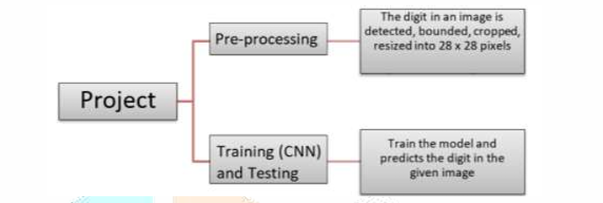

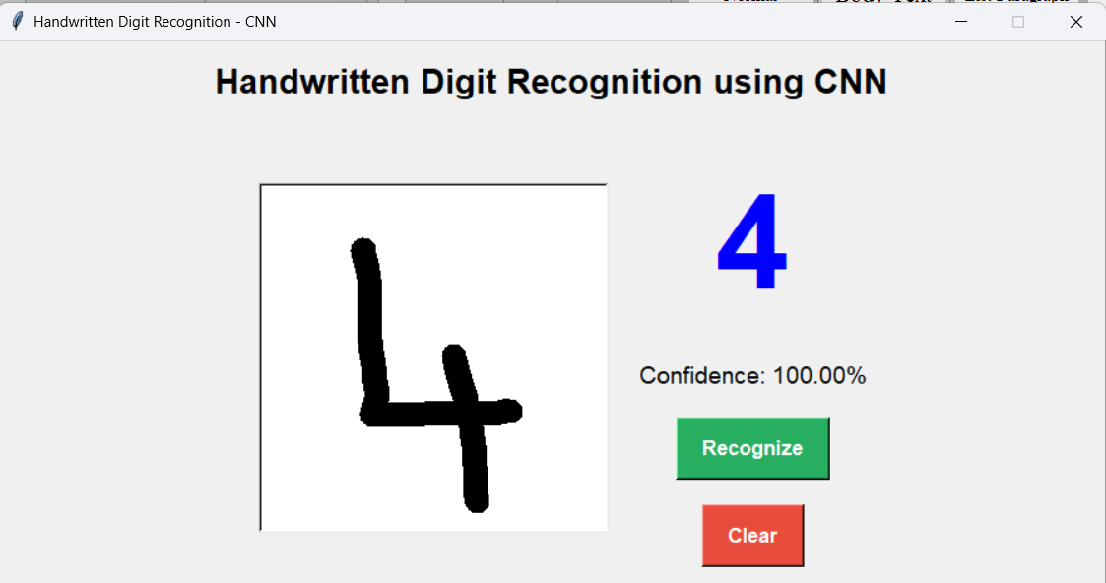

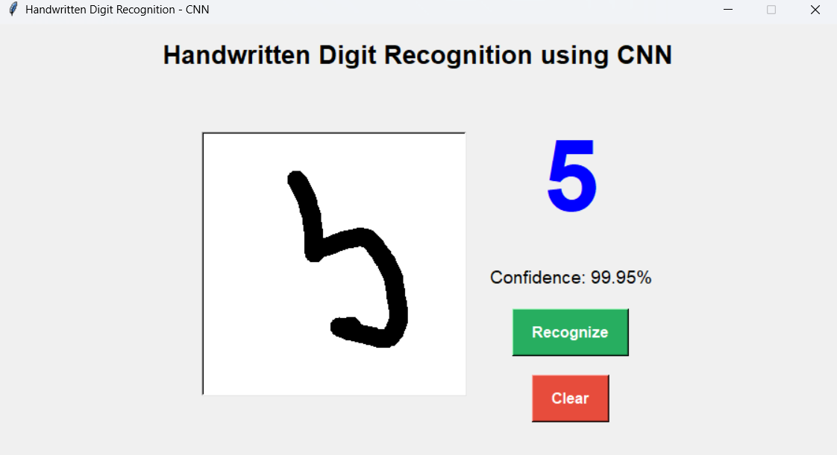

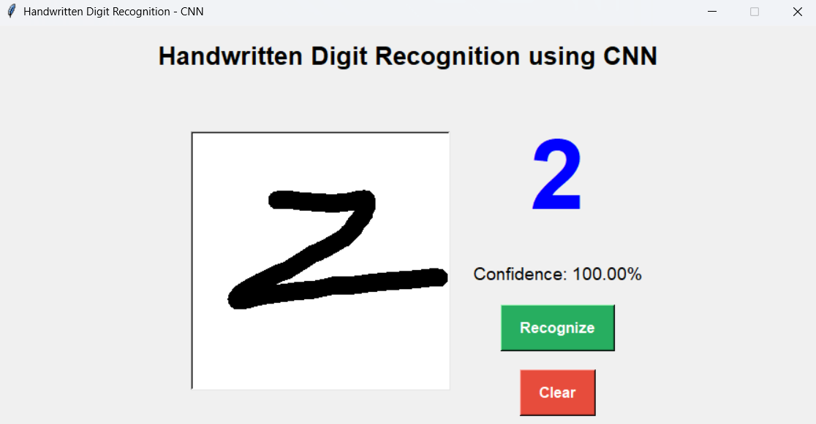

CONCLUSION

The Handwritten Digit Recognition system developed using OpenCV and Convolutional Neural Networks (CNNs) successfully demonstrates an efficient and accurate approach to interpreting handwritten numeric input. By integrating robust image preprocessing techniques with a deep learning–based classification model, the system effectively recognizes digits drawn by users with high confidence and real-time responsiveness. The preprocessing pipeline—consisting of grayscale conversion, thresholding, noise removal, cropping, resizing, and normalization—ensures that the handwritten input is transformed into a consistent format suitable for prediction.
The CNN model learns hierarchical patterns such as edges, curves, and stroke orientations, enabling it to generalize well across diverse handwriting styles. With the MNIST dataset serving as a strong training foundation, the network achieves reliable performance and maintains stability even when presented with irregular or imperfect user-drawn digits. The graphical interface further enhances usability, making digit recognition intuitive and interactive for end users.
Overall, this project validates the effectiveness of combining classical computer vision with modern deep learning techniques for handwritten digit classification. It also establishes a scalable foundation for future extensions such as multi-digit recognition, real-time camera-based digit input, deployment on mobile/embedded platforms, and integration with broader OCR systems. This work highlights the power of CNNs in pattern recognition tasks and showcases their practical value in real-world human–computer interaction solutions.

FUTURE SCOPE:

The Handwritten Digit Recognition system built using OpenCV and CNNs provides a solid
foundation for several advanced enhancements and real-world applications. As technology and deep learning architectures continue to evolve, this project can be expanded in multiple impactful directions:

1. Multi-Digit and Full OCR Recognition
Extend the system to recognize complete numbers, words, or paragraphs instead of single digits.
Integrating advanced OCR techniques can transform the model into a full handwriting recognition engine.

2. Deployment on Mobile and Embedded Devices
Optimize and compress the CNN model using TensorFlow Lite or ONNX to run efficiently on mobile
phones, tablets, Raspberry Pi, and edge AI devices, enabling offline real-time digit recognition.

3. Real-Time Camera-Based Digit Capture
Incorporate live video input to allow recognition of digits written on paper via a webcam. This opens
opportunities in banking, education, and digital document processing.

4. Enhanced Data Augmentation Techniques
Introduce more sophisticated augmentation such as elastic distortions, stroke thickening/thinning, and
generative models (GANs) to make the system more robust to messy handwriting.

5. Integration with Advanced Deep Learning Models
Explore newer architectures such as:
- Residual Networks (ResNet)
- Inception Networks
- Vision Transformers (ViT)
- Hybrid CNN-RNN models
- These can significantly increase recognition accuracy and generalization.

6. Cloud-Based API Service
Deploy the model as a cloud API using Flask, FastAPI, or Django, enabling integration into larger
systems such as automated form processing, digital examinations, or document verification.

7. Support for Multiple Languages and Scripts
Extend the model to recognize handwritten characters from different languages (Hindi, Tamil, Telugu,
etc.) by training on diversified datasets.

8. User History and Analytics
Add features to track user drawings, provide performance analytics, and deliver personalized
feedback, useful in educational applications.

9. Interactive Learning Modules
Build a gamified module to help children practice handwriting and receive automated scoring based
on shape and correctness.

10. Integration with Industry Applications
Potential use cases include:
- Bank cheque processing
- Postal code reading
- Automated form digitization
- Smart classroom applications
- Assistive technologies for differently abled users

REFERENCES:

- LeCun, Y., Bottou, L., Bengio, Y., & Haffner, P. (1998). Gradient-Based Learning Applied to Document Recognition. Proceedings of the IEEE.
- MNIST Dataset – Yann LeCun. Available at: http://yann.lecun.com/exdb/mnist/
- OpenCV Documentation. Open Source Computer Vision Library. Available at: https://docs.opencv.org/
- TensorFlow Official Documentation. Deep Learning Framework. Available at: https://www.tensorflow.org/
- Keras API Documentation. Deep Learning Library for Python. Available at: https://keras.io/
- PyTorch Documentation. Deep Learning Framework by Facebook AI Research. Available at: https://pytorch.org/docs/
- NumPy Documentation. Scientific Computing Library for Python. Available at: https://numpy.org/doc/
- Matplotlib Documentation. Visualization Library for Python. Available at: https://matplotlib.org/
- Scikit-learn Documentation. Machine Learning Library for Python. Available at: https://scikit-learn.org/
- Goodfellow, I., Bengio, Y., & Courville, A. (2016). Deep Learning. MIT Press.
- GitHub Link: https://github.com/maiharsait/Handwritten-Digital-Recognition-using-OpenCv-and-CNNs

